[1]

Contact-Aided Compliant Joint

First A. Author, Second B. Author, Jr., and Third C. Author, Member, IEEE

*Abstract*— This electronic document is a “live” template. The various components of your paper [title, text, heads, etc.] are already defined on the style sheet, as illustrated by the portions given in this document.

# INTRODUCTION

Notch-tube compliant joint mechanisms have increasingly been used to construct miniature dexterous medical instruments, such as articulated fiber-optic endoscopic cameras, articulated lasers, suction and irrigation probes, as well as wristed forceps, scissors and drills [1]–[10]. This technology has been adopted in endoscope-guided neurosurgery, as it requires 1-2 mm diameter tools that can reach areas visualized by the endoscope which is enabled by creating dexterous wristed instruments [1]–[7]. The workspace of these instruments are confined to 5-20mm [8]. Notch-tube compliant joints are fabricated by cutting macro-scale patterns into a single nitinol tube. These monolithic geometries can be articulated in bending using an actuation cable and require minimal assembly with a few additional components. Thus, this joint type can be manufactured at the millimeter scale and are frequently favored over pin-jointed mechanisms when constructing tools for working inside confined body cavities. Notched tubes can be cut in many different topologies that are classified as asymmetric or symmetric and different combinations of notches create different degrees-of-freedom (DOF) and directions of bending. The simplest notch topology reported is a rectangular shape [1], [9]–[11]. As the technology has progressed, modifications to this basic topology have improved performance, for example one feature change includes changing the notch shape to prevent the joint from reaching the material’s elastic strain limit by tapering the notches [12], [13]. To reduce strain concentrations, fillets are added to the corners of the notch [12], [14]–[16]. Also, “tip-first-closure” is a concept that was recently explored where the depth of the notches is varied such that the most distal end of the joint articulates closed before the more proximal notches [2]. As a result of these three modifications, the strain profile within the joint has been improved and the mechanism bends in a compact and space-efficient shape. However, when the joint is scaled below the 1-2 mm diameter range, the joint’s stiffness is significantly reduced. The fundamental trade-off in these joints is stiffness and compactness; it is challenging to achieve a joint that is simultaneously compact and stiff enough to manipulate tissue. Rectangular notch joints have been studied to achieve a high compactness: asymmetric notch topologies bend into themselves during articulation and are therefore more compact than symmetric designs, spacing between notches have been minimized to reduce the overall joint bending radius of curvature and using the fewest number of notches with maximum width ensures the most compact design to achieve a desired bending angle [1], [2], [3]. However, these strategies oppose the strategies used to increase joint stiffness, as the joint’s tube diameter is decreased and notch cut depth and width are increased. Joint stiffness is critical for tissue manipulation during dissection and tip forces at these joints typically undergo significant deflection (error-motions) [3], [16]. This work aims to address the trade-off between joint range of motion (compactness) and stiffness for conventional topologies by introducing “contact-aids” into the design of notch-tube compliant mechanisms.

Contact-aided compliant mechanisms (CCMs) are a category of joint designs in which parts of the compliant members contact or interfere with one another to improve the mechanisms’ performance [19]. These devices have been studied extensively and have shown promise in aerospace, medical and biomimetic inspired robotics applications [20]–[23]. In particular, CCMs have been used to affect the “shape” that the complaint mechanism undertakes during actuation, and separately, CCMs have been employed to increase the directional stiffness of a compliant joint [20]. This work presents a new CCM notch-tube cutting geometry that was developed to increase the compact bending of asymmetric notch designs by changing their shape while articulating, and simultaneously, increasing the tip loads that the joint can support during articulation. To the best of our knowledge, this work presents the first example of a CCM incorporated into a notched tube-compliant mechanism.

We begin by presenting the joint design. Then we present the kinematics model to predict the behavior of the joint followed by experimental results to verify the accuracy of the kinematics model. The aim of this study is to model the kinematics of a contact-aided mechanism and experimentally verify the accuracy of the model. It also outlines the design and fabrication of a 3 degree-of-freedom (DOF) notched wrist that employs the contact-aided mechanism compliant joint.

# Design Concept

## Notch Tube Joint Design

The contact aid changes the shape that the joint takes on and increases the stiffness of the tip.

<figure of geometry schematic – labeled ccm joint + a bent one>

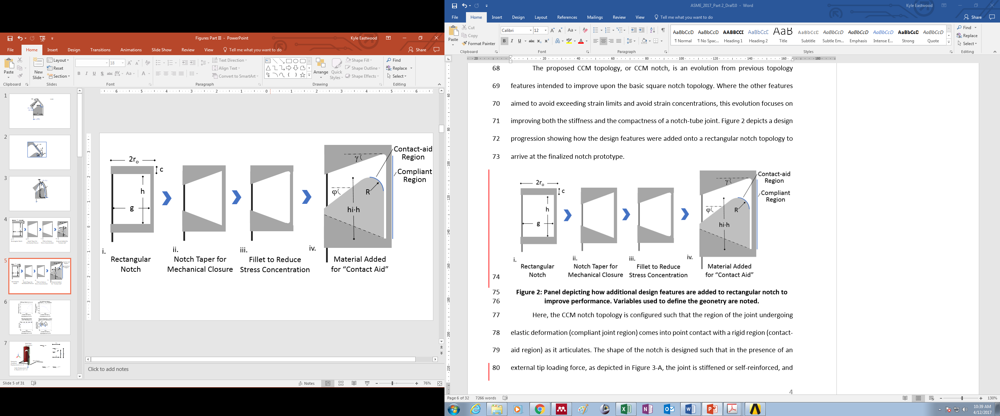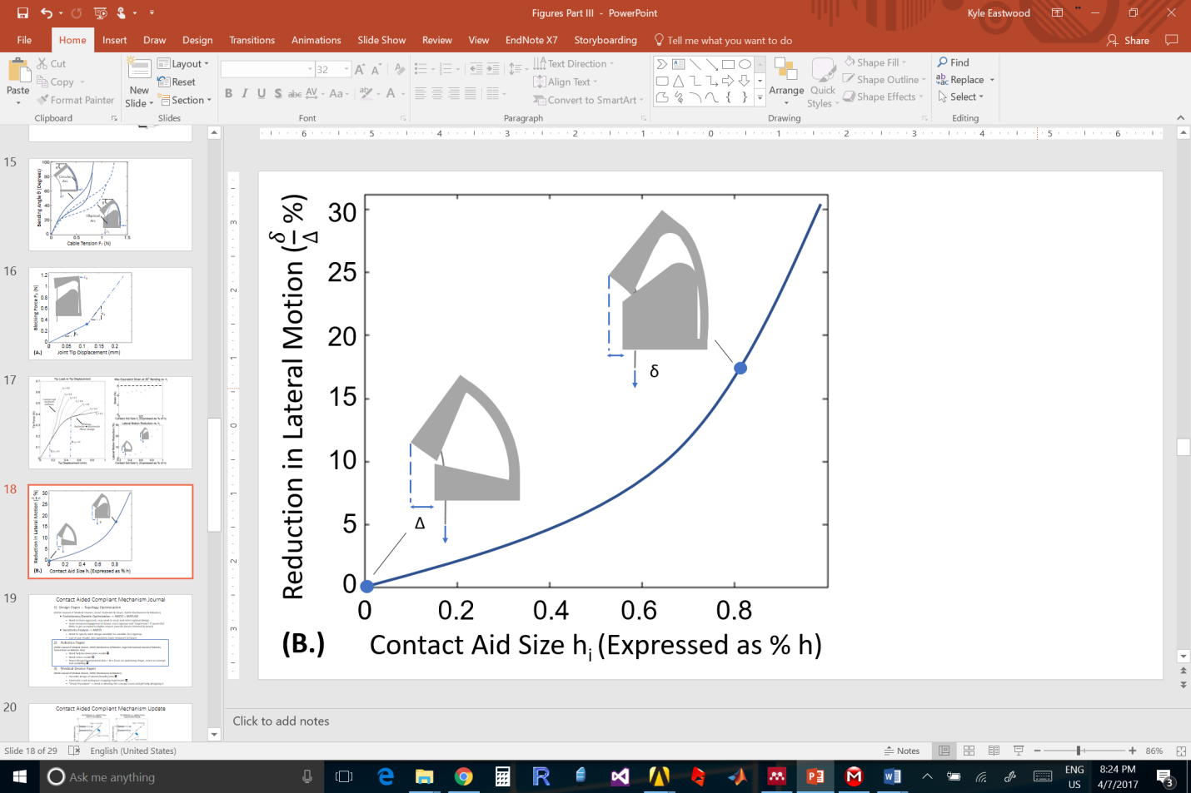

1. Testing and fabrication of sample

The contact-aided compliant mechanism (CCM) notch topology allows the region of the joint undergoing elastic deformation (compliant joint region) to contact a rigid region (contact-aid region) as it articulates. The notch shape is designed so the presence of an external tip loading force, as shown in figure XXX., <ensure figure has tip loading force> the joint is self-reinforced and becomes stiffer while still bending when a moment is applied by the actuation cable. For rectangular asymmetric notches, external forces applied in the direction shown in figure XXX. cause the largest displacements. This occurs because the second-moment of area of the compliant region is the smallest in this orientation and the applied load cannot be opposed by the actuation cable. The CCM topology reinforces the compliant region, thereby addressing this vulnerability for asymmetric notches. The contact-aid also influences the shape of the notch’s compliant region when actuated. The compliant region takes on an elliptical shape, whereas a rectangular notch joint takes on a circular arc, while bending thereby achieving a more compact bent shape with less lateral movement. The benefits of improved stiffness and bending compactness are illustrated in figure XXX.

## Roll Pitch Roll Wrist Design Overview

<schematic of how the pitch is incorporated with roll and roll>

# Kinematics Modeling

## Kinematics of the Notch Tube

In order to predict the relationship between cable displacement and bending angle for this type of joint, an approximate kinematics model was developed based on the geometry of an individual notch. The kinematics model approximates the behavior of the joint by assuming that the majority of bending occurs near the contact-aided region, and that the compliant component of the joint wraps around the filleted edge of the contact-aided region, as shown in Figure 7. The forward kinematics mapping between the input cable displacement and the output joint bending angle is approximated, using the small angle assumption, as follows:

**<equation 1>**

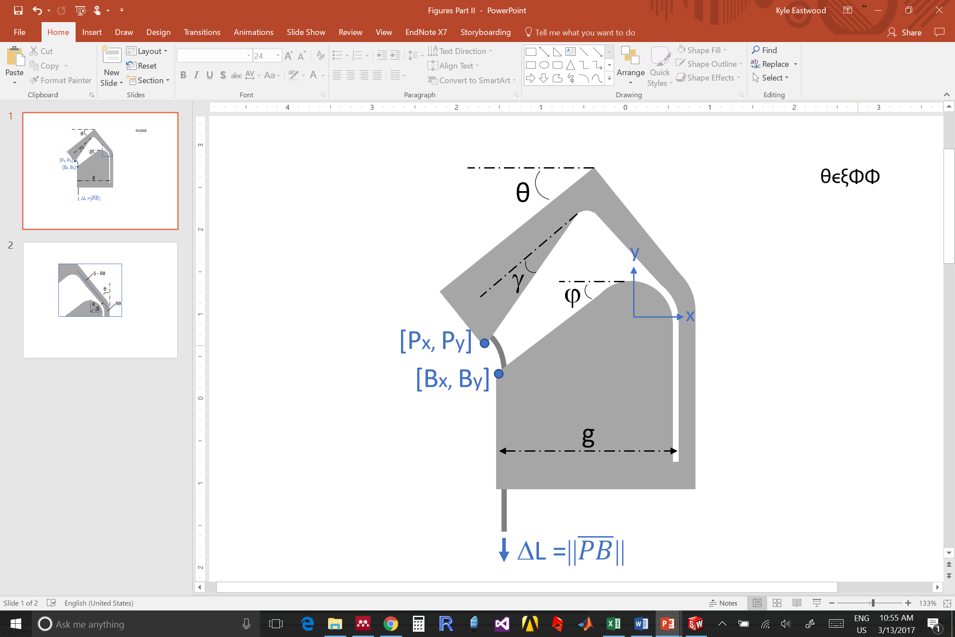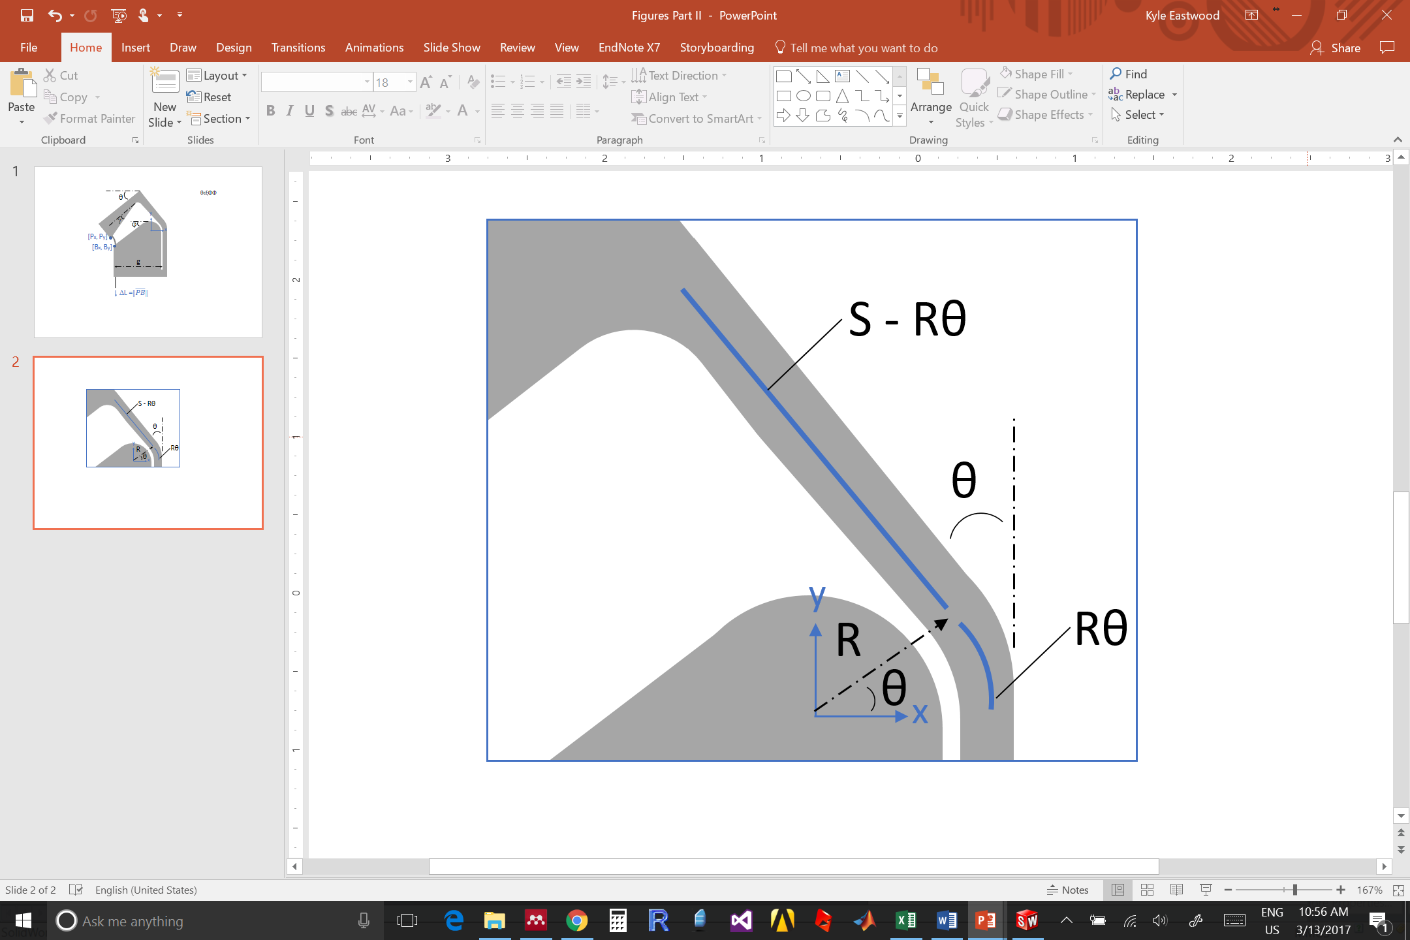

The inverse kinematics mapping is determined by approximating the locations of the top corner of the notch with coordinates [Px,Py] with respect to the bottom corner of the notch with coordinates [Bx, By], as follows:

**<Equations 2, 3,4 >**

where *S = (1-hi)⋅h* and $φ$ is the angle of the bottom taper as shown in Figure 7.

Equation formatting:

       

Note that the equation is centered using a center tab stop. Be sure that the symbols in your equation have been defined before or immediately following the equation. Use “(1)”, not “Eq. (1)” or “equation (1)”, except at the beginning of a sentence: “Equation (1) is . . .”

## Kinematics of the RPR Wrist

# Prototype fabrication

## Roll Pitch Roll Wrist

The RPR consists of a notch tube joint with a concentric tube sleeve over top to facilitate the RPR mechanism. The CCM notch-tube joint was fabricated through laser cutting (Pulse Systems, USA). The rectangular notch joint design of equivalent tube radii as well as notch cut depth g, notch height h and notch spacing c, as shown in -A was cut using a standard two-flute end-mill (1/16” or 0.0625” diameter) on a Minitech Mini-Mill (Minitech Machinery, USA). The intent of this comparison is to demonstrate how the behavior of a CCM notch augments the basic notch shape once the contact-aid topology is added to its geometry, effectively comparing hi = 0.8 with hi = 0. The width of the slit feature in the CCM design was limited by the performance of the laser; the smallest width that can be cut is 0.05 mm. Further, because of fabrication constraints, the slits were cut off-axis to the tube at an angle of 15o as shown in -B.

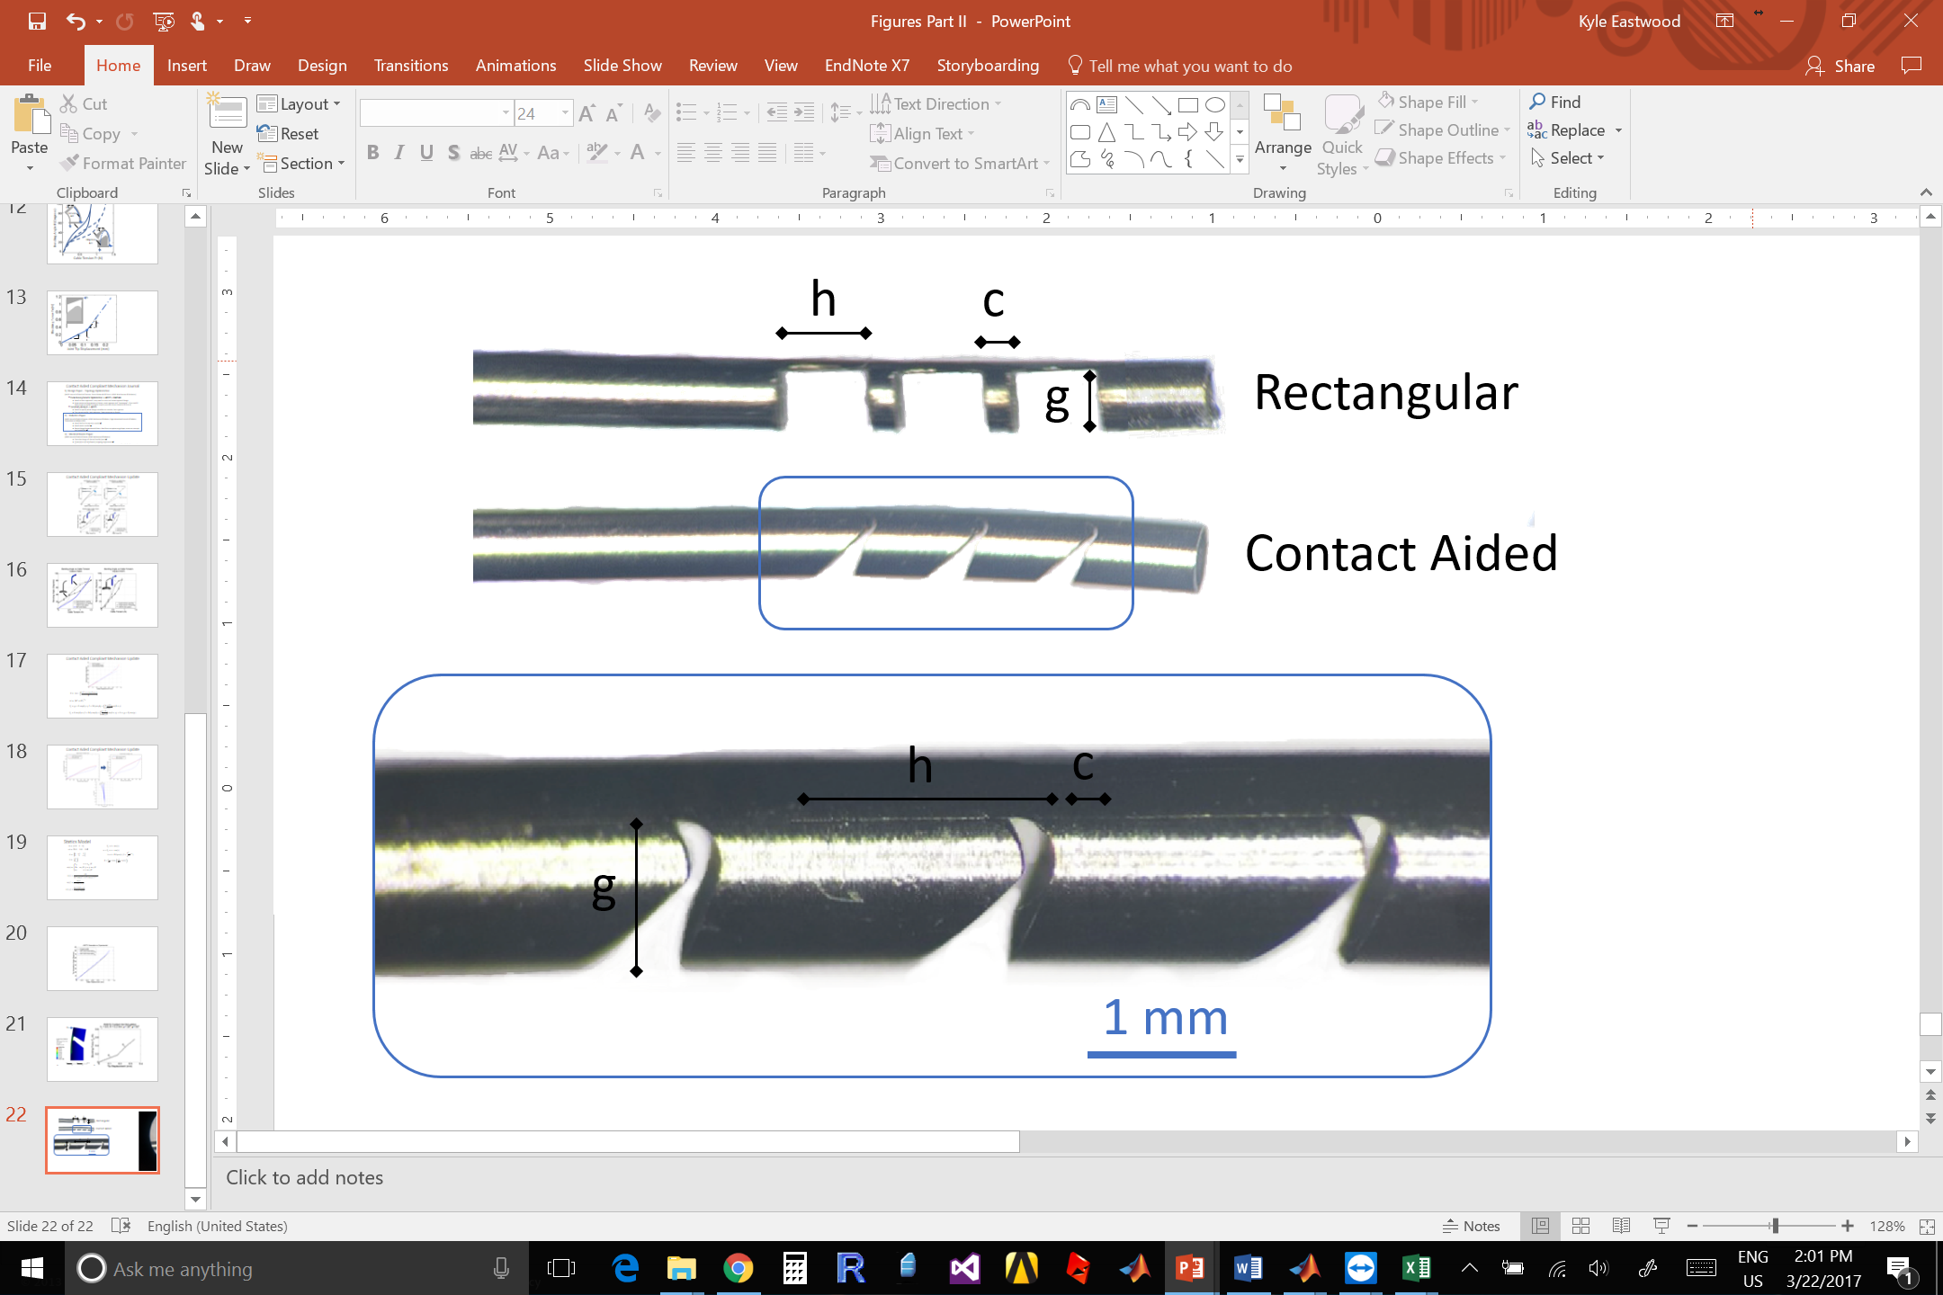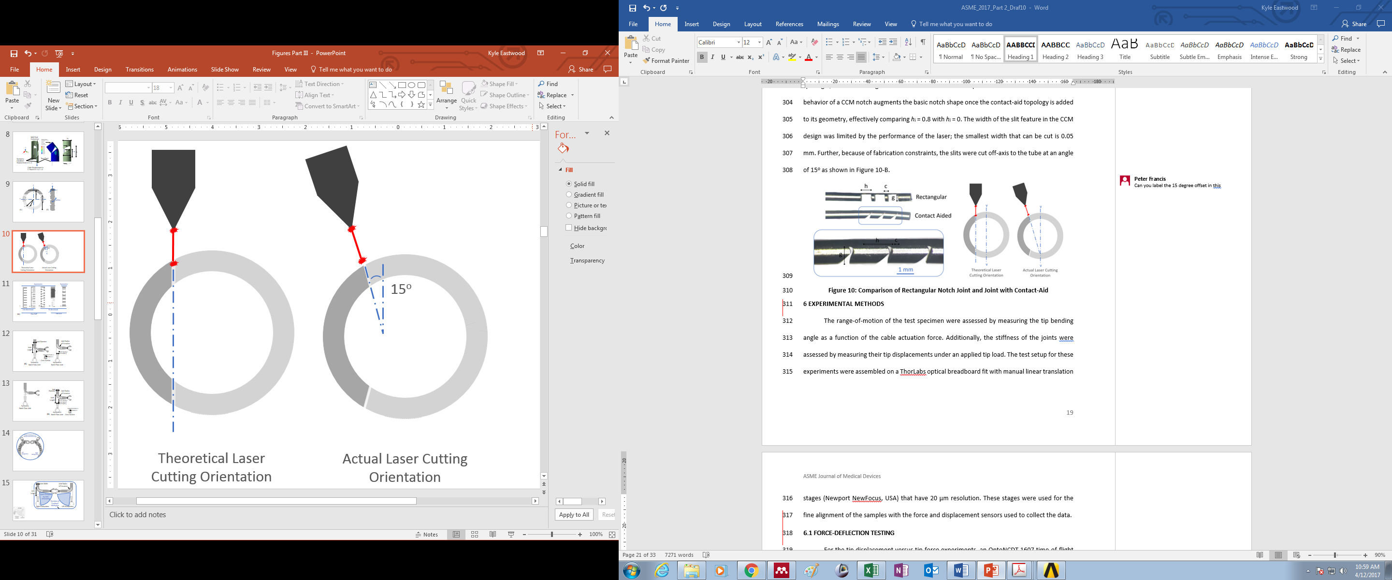

## DVRK Base

# Experimental validation of kinematics modeling

## Assessment of Contact-Aided Joint

An experiment to validate the accuracy of the kinematics model was conducted with the RPR prototype, where tip deflection vs. applied force and bending angle vs. cable tension were characterized. A pair of Flea3 1.3 MP cameras (Point Grey, Vancouver, Canada) were arranged in a stereo-configuration and calibrated using the MATLAB® Camera Calibration Toolbox. These cameras tracked the shape, radius of curvature and bending angle of the joints while an FSH00095 JR S-Beam Load Cell (FUTEK, USA) collected cable tension measurements. The error of the measurement system was determined as ± [0.01-0.1] mm in measuring known radii of curvatures in the range of [3-15] mm. This set-up is shown in figure XXX.

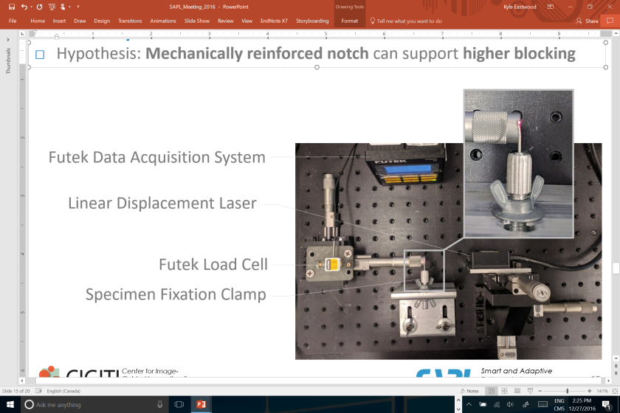

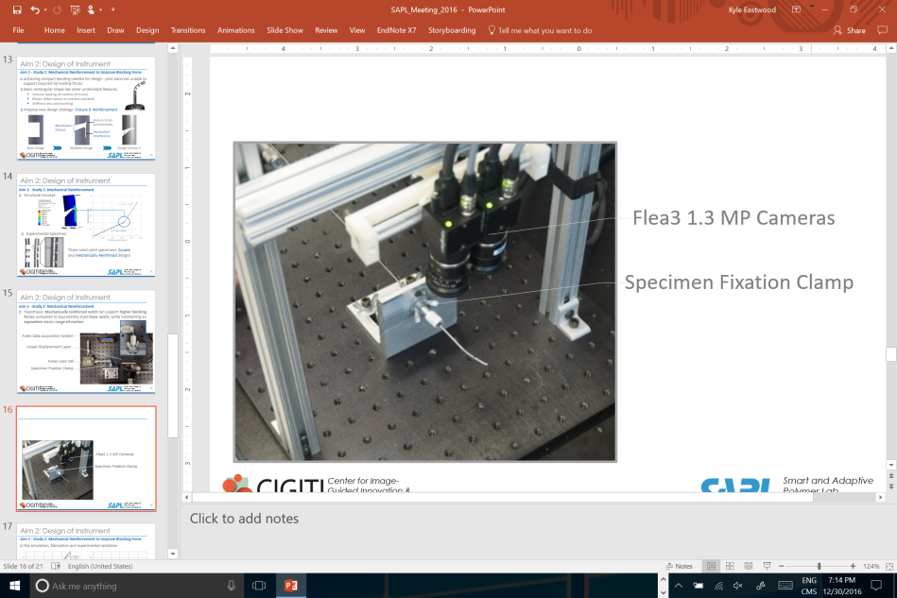

1. Testing and fabrication of sample

The RPR prototype was stabilized on a 3D-printed fixation clamp as shown in figure XXX.

*** replace with larger notch tube

1. Testing and fabrication of sample

The range-of-motion of the test specimen were assessed by measuring the tip bending angle as a function of the cable actuation force. Additionally, the stiffness of the joints were assessed by measuring their tip displacements under an applied tip load. The test setup for these experiments were assembled on a ThorLabs optical breadboard fit with manual linear translation stages (Newport NewFocus, USA) that have 20 µm resolution. These stages were used for the fine alignment of the samples with the force and displacement sensors used to collect the data.

To verify the anticipated effects of the CCM notches from the kinematics model, the physical prototypes were compared against an equivalent square notch design with the same cut depth, g and width, h. The two notches are shown side by side in figure XXX.

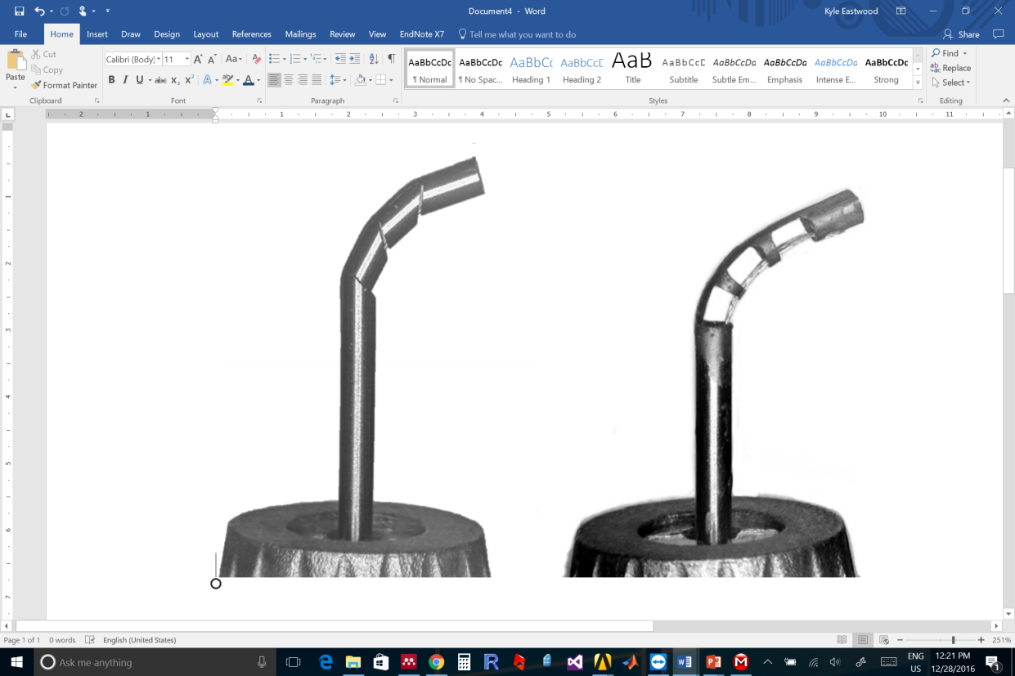

By inspecting these images, it can be seen that the CCM notch takes on a more compact bending shape with less lateral motion.

The following presents tip deflection vs. applied force experimental results of the CCM notched tube and square notched tube. The physical measurements were repeated five times for each data point and the mean and standard error of the measurements are shown.

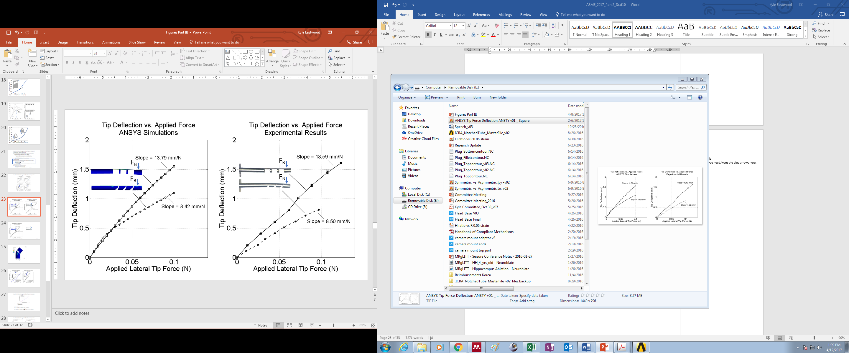***need to replace figure with updated one

1. Blocking Force of Square Joint and Contact-aided Joint

Figure XXX. compares the bending angle vs. cable tension of the CCM notch and square notch under physical experimental conditions and the Matlab kinematics model.

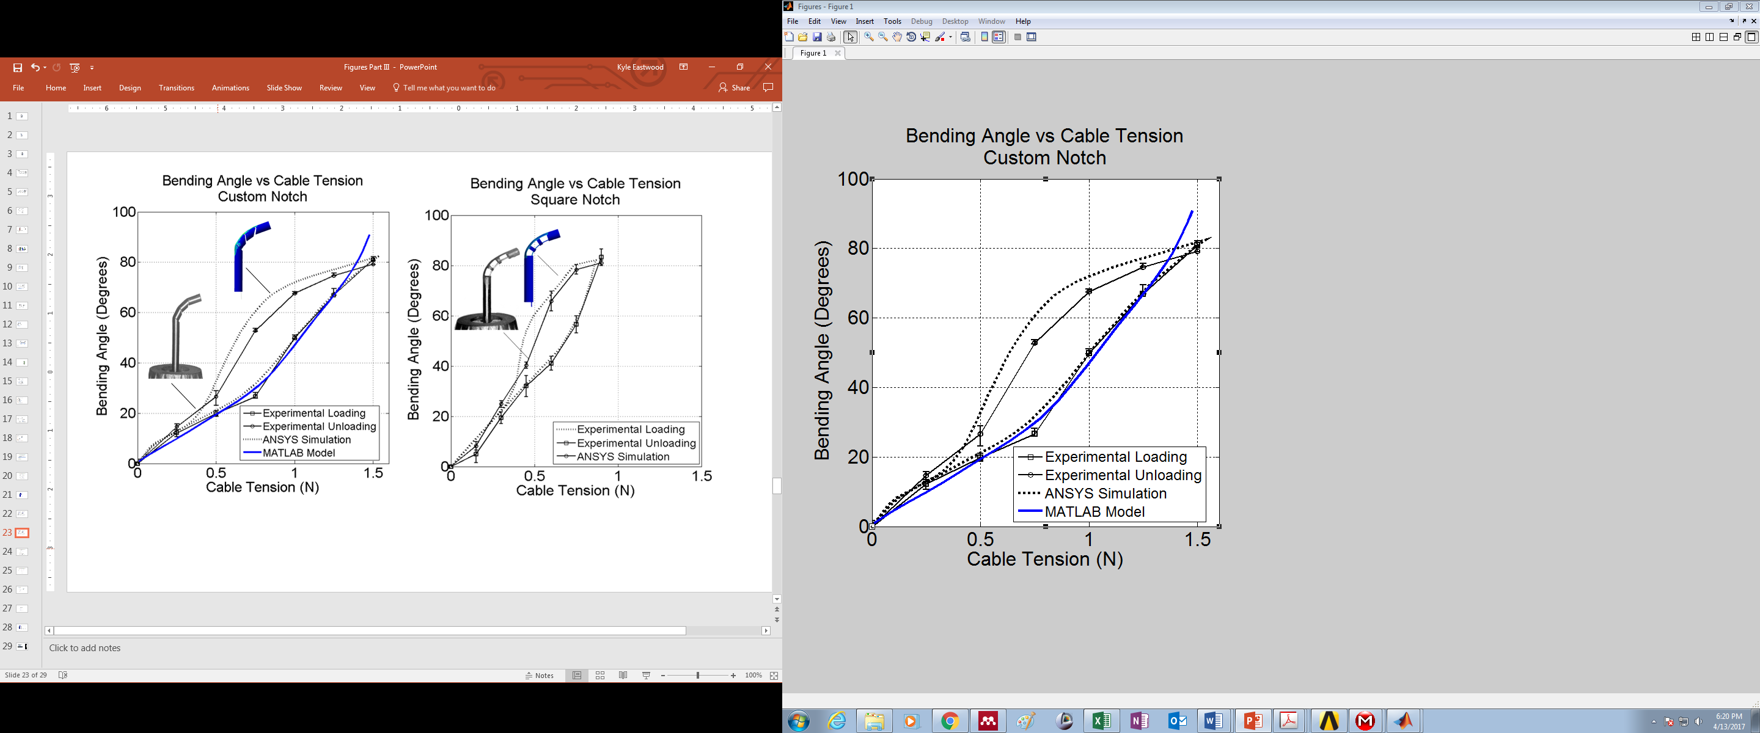***need to replace figure with updated one that only has the experimental results in it with the kinematics

1. Bending Angle versus Cable Tension

## Accuracy of Roll Pitch Roll Wrist vs. Kinematics Model

<EM tracker to measure the tip position of the RPR wrist vs. expected modeling from kinematics>

# Discussion

Insert discussion here.

1. Table Type Styles

| Table Head | Table Column Head | | |
| --- | --- | --- | --- |
| Table column subhead | Subhead | Subhead |
| copy | More table copya |  |  |

a. Sample of a Table footnote. (Table footnote)

1. Example of a figure caption. *(figure caption)*

Figure Labels: Use 8 point Times New Roman for Figure labels. Use words rather than symbols or abbreviations when writing Figure axis labels to avoid confusing the reader. As an example, write the quantity “Magnetization”, or “Magnetization, M”, not just “M”. If including units in the label, present them within parentheses. Do not label axes only with units. In the example, write “Magnetization (A/m)” or “Magnetization {A[m(1)]}”, not just “A/m”. Do not label axes with a ratio of quantities and units. For example, write “Temperature (K)”, not “Temperature/K.”

# Conclusion

A conclusion section is not required. Although a conclusion may review the main points of the paper, do not replicate the abstract as the conclusion. A conclusion might elaborate on the importance of the work or suggest applications and extensions.

Appendix

Appendixes should appear before the acknowledgment.

Acknowledgment

The preferred spelling of the word “acknowledgment” in America is without an “e” after the “g”. Avoid the stilted expression, “One of us (R. B. G.) thanks . . .” Instead, try “R. B. G. thanks”. Put sponsor acknowledgments in the unnumbered footnote on the first page.

References

1. G. O. Young, “Synthetic structure of industrial plastics (Book style with paper title and editor),” in *Plastics*, 2nd ed. vol. 3, J. Peters, Ed. New York: McGraw-Hill, 1964, pp. 15–64.
2. W.-K. Chen, *Linear Networks and Systems* (Book style)*.* Belmont, CA: Wadsworth, 1993, pp. 123–135.
3. H. Poor, *An Introduction to Signal Detection and Estimation*. New York: Springer-Verlag, 1985, ch. 4.
4. B. Smith, “An approach to graphs of linear forms (Unpublished work style),” unpublished.
5. E. H. Miller, “A note on reflector arrays (Periodical style—Accepted for publication),” *IEEE Trans. Antennas Propagat.*, to be published.
6. J. Wang, “Fundamentals of erbium-doped fiber amplifiers arrays (Periodical style—Submitted for publication),” *IEEE J. Quantum Electron.*, submitted for publication.
7. C. J. Kaufman, Rocky Mountain Research Lab., Boulder, CO, private communication, May 1995.
8. Y. Yorozu, M. Hirano, K. Oka, and Y. Tagawa, “Electron spectroscopy studies on magneto-optical media and plastic substrate interfaces(Translation Journals style),” *IEEE Transl. J. Magn.Jpn.*, vol. 2, Aug. 1987, pp. 740–741 [*Dig. 9th Annu. Conf. Magnetics* Japan, 1982, p. 301].
9. M. Young, *The Techincal Writers Handbook.* Mill Valley, CA: University Science, 1989.
10. J. U. Duncombe, “Infrared navigation—Part I: An assessment of feasibility (Periodical style),” *IEEE Trans. Electron Devices*, vol. ED-11, pp. 34–39, Jan. 1959.
11. S. Chen, B. Mulgrew, and P. M. Grant, “A clustering technique for digital communications channel equalization using radial basis function networks,” *IEEE Trans. Neural Networks*, vol. 4, pp. 570–578, July 1993.
12. R. W. Lucky, “Automatic equalization for digital communication,” *Bell Syst. Tech. J.*, vol. 44, no. 4, pp. 547–588, Apr. 1965.
13. S. P. Bingulac, “On the compatibility of adaptive controllers (Published Conference Proceedings style),” in *Proc. 4th Annu. Allerton Conf. Circuits and Systems Theory*, New York, 1994, pp. 8–16.
14. G. R. Faulhaber, “Design of service systems with priority reservation,” in *Conf. Rec. 1995 IEEE Int. Conf. Communications,* pp. 3–8.
15. W. D. Doyle, “Magnetization reversal in films with biaxial anisotropy,” in *1987 Proc. INTERMAG Conf.*, pp. 2.2-1–2.2-6.
16. G. W. Juette and L. E. Zeffanella, “Radio noise currents n short sections on bundle conductors (Presented Conference Paper style),” presented at the IEEE Summer power Meeting, Dallas, TX, June 22–27, 1990, Paper 90 SM 690-0 PWRS.
17. J. G. Kreifeldt, “An analysis of surface-detected EMG as an amplitude-modulated noise,” presented at the 1989 Int. Conf. Medicine and Biological Engineering, Chicago, IL.
18. J. Williams, “Narrow-band analyzer (Thesis or Dissertation style),” Ph.D. dissertation, Dept. Elect. Eng., Harvard Univ., Cambridge, MA, 1993.
19. N. Kawasaki, “Parametric study of thermal and chemical nonequilibrium nozzle flow,” M.S. thesis, Dept. Electron. Eng., Osaka Univ., Osaka, Japan, 1993.
20. J. P. Wilkinson, “Nonlinear resonant circuit devices (Patent style),” U.S. Patent 3 624 12, July 16, 1990.

1. *Research supported by ABC Foundation.

   F. A. Author is with the National Institute of Standards and Technology, Boulder, CO 80305 USA (corresponding author to provide phone: 303-555-5555; fax: 303-555-5555; e-mail: author@ boulder.nist.gov).

   S. B. Author, Jr., was with Rice University, Houston, TX 77005 USA. He is now with the Department of Physics, Colorado State University, Fort Collins, CO 80523 USA (e-mail: author@lamar. colostate.edu).

   T. C. Author is with the Electrical Engineering Department, University of Colorado, Boulder, CO 80309 USA, on leave from the National Research Institute for Metals, Tsukuba, Japan (e-mail: author@nrim.go.jp).